My visit to
Portland Maritime Discovery Centre

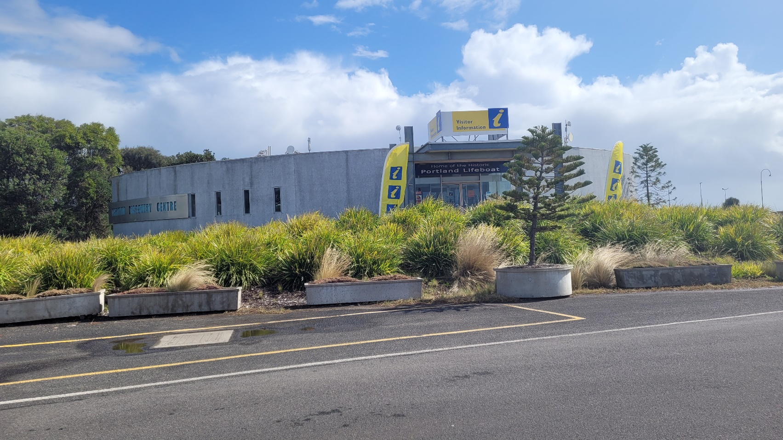

I am going to the Portland Maritime Discovery Centre. The Maritime Discovery Centre is a safe place to visit.

First, I have to walk up the slope to the entrance.

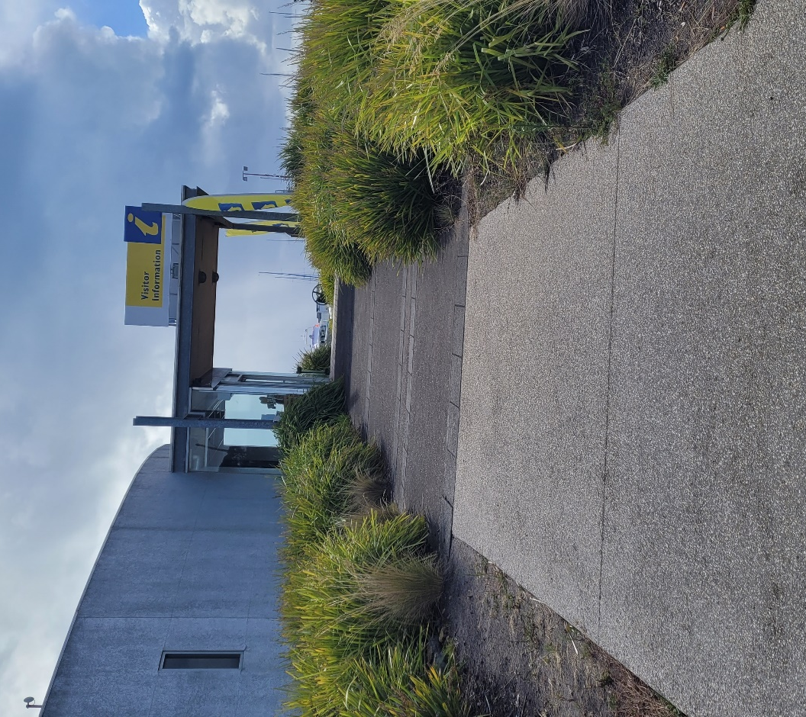

I walk through the front glass sliding doors into the entrance.

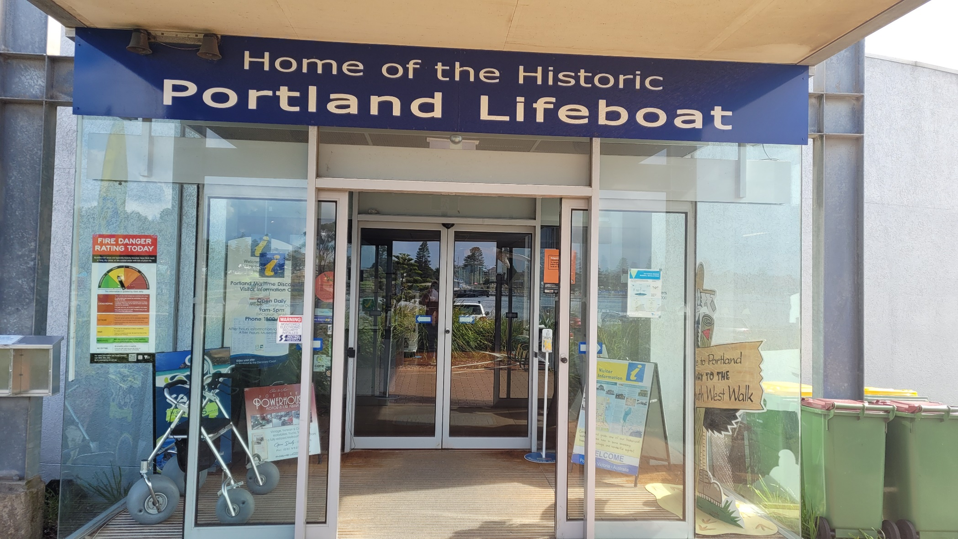

Here I can visit the Tourism Information Centre, look through the Maritime Museum and visit the Captain’s Galley Café and Bar.

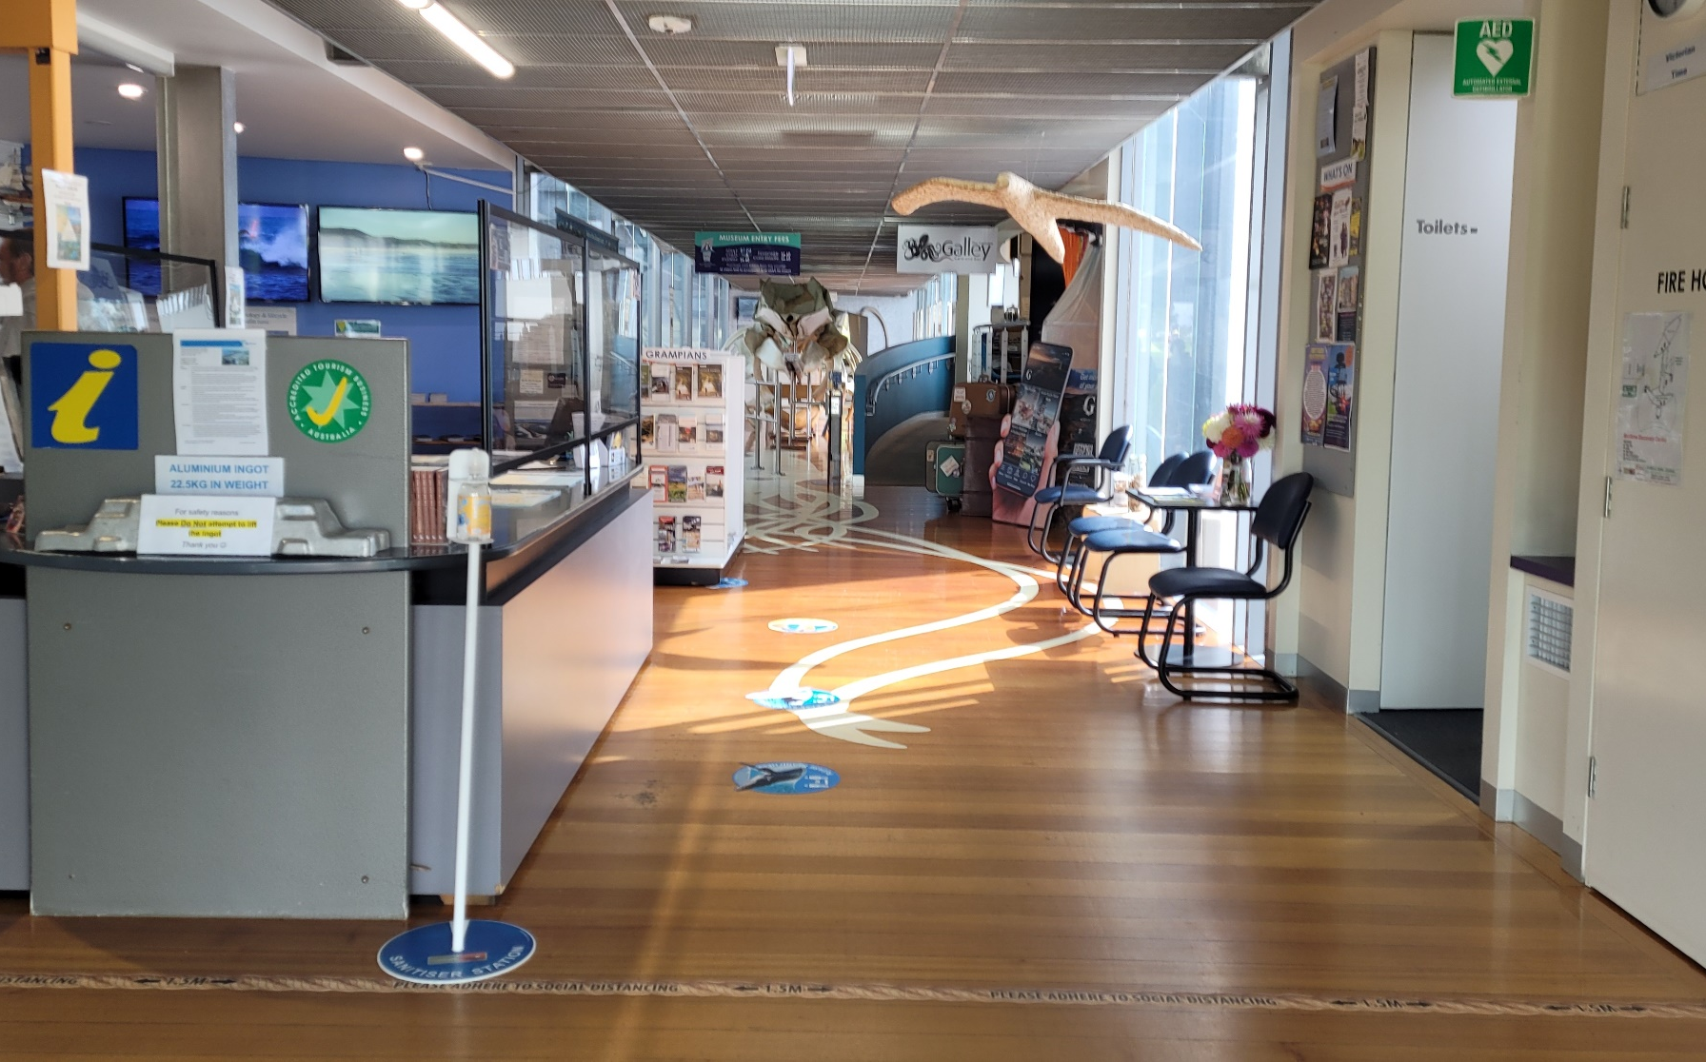

I can go into the Visitor Information Centre and look at what there is to do and see in and around the Glenelg Shire.

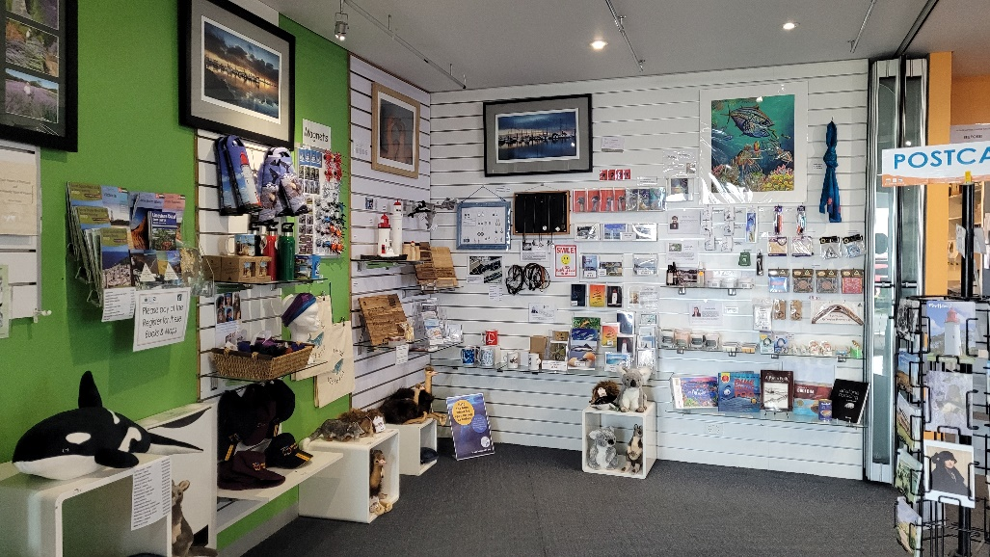

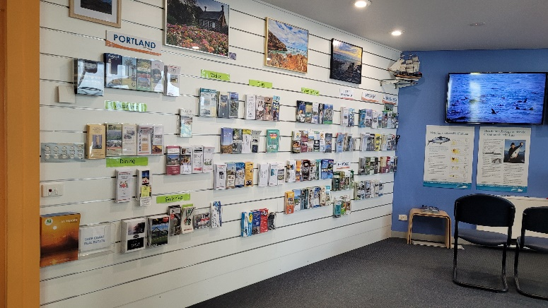
There are people who work at the Maritime Discovery Centre. They are called Visitor Services Officers. They wear a uniform. I can ask them questions about anything in the museum or what there is to do and see in and around our Shire.

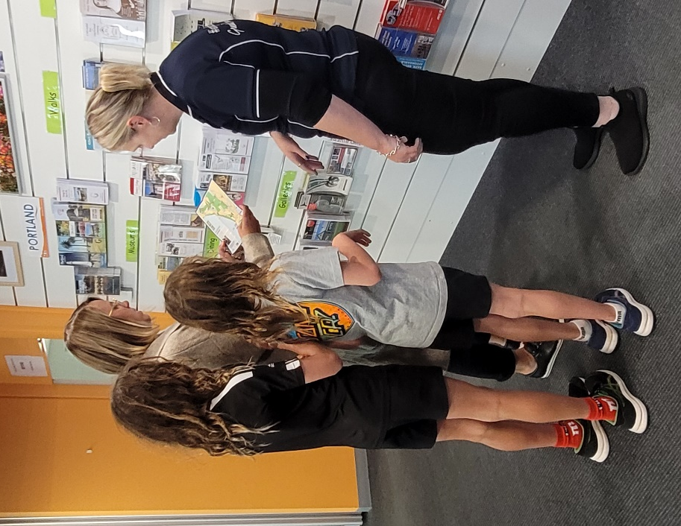

At the Maritime Discovery Centre there will be a turnstile to get into the Maritime Museum. There are special things to see in the museum and I will need a token to enter. My support person can help me get a token from a Visitor Services Officer.

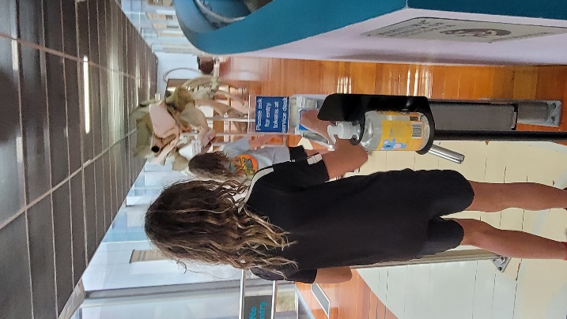
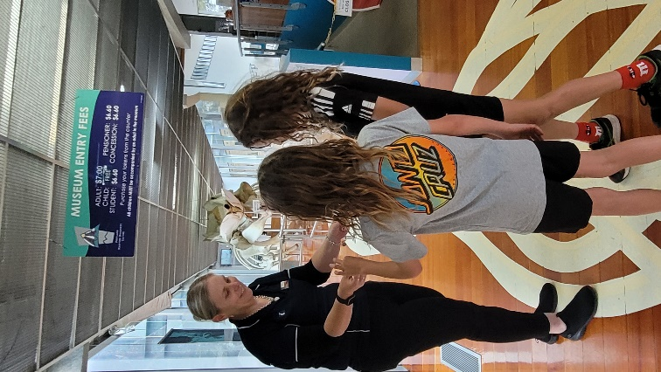
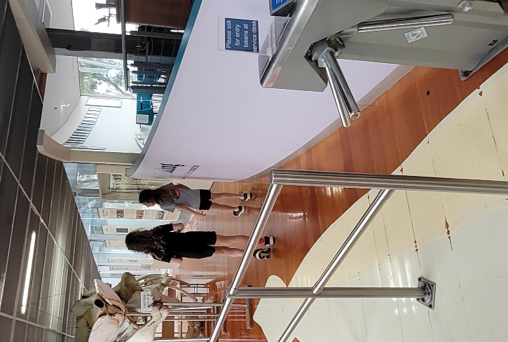
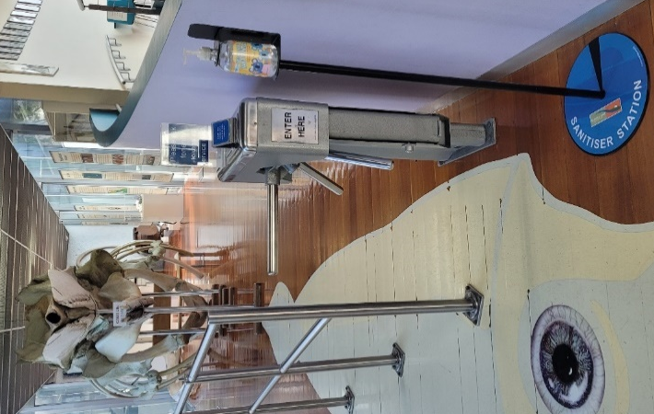

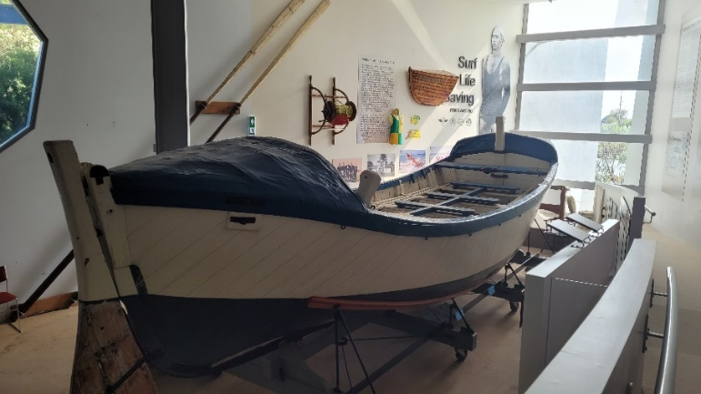
In the Maritime Museum I can look at the whale skeleton and the Portland Lifeboat. There is lots of Portland maritime history to see and read about.
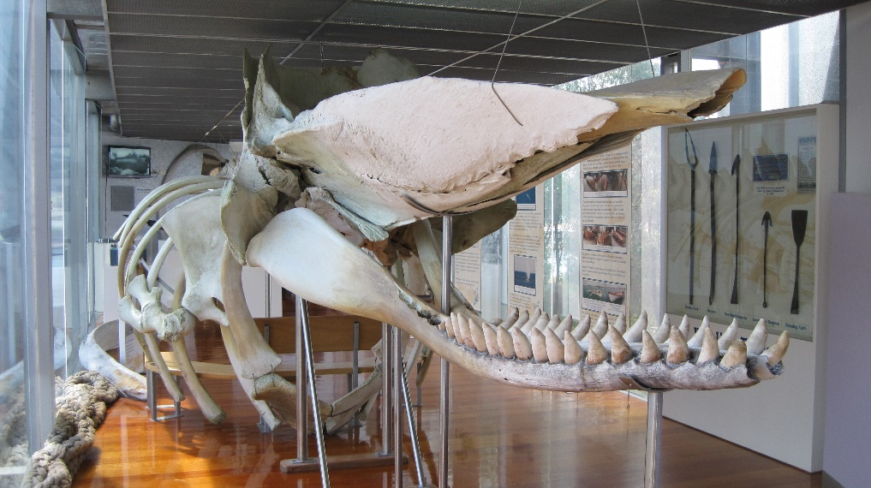
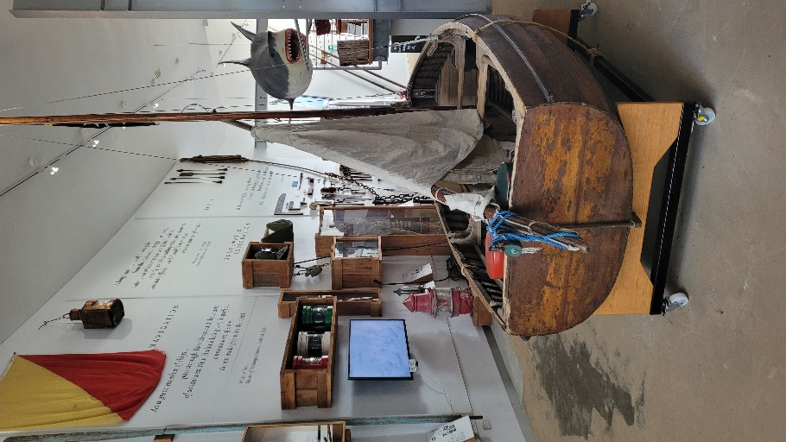
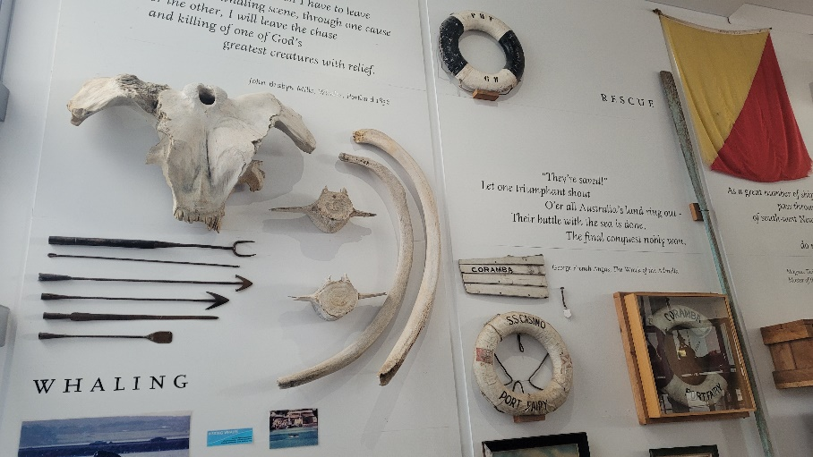
I can walk up the ramp to the Captains Galley Café and Bar and have a drink and something to eat.

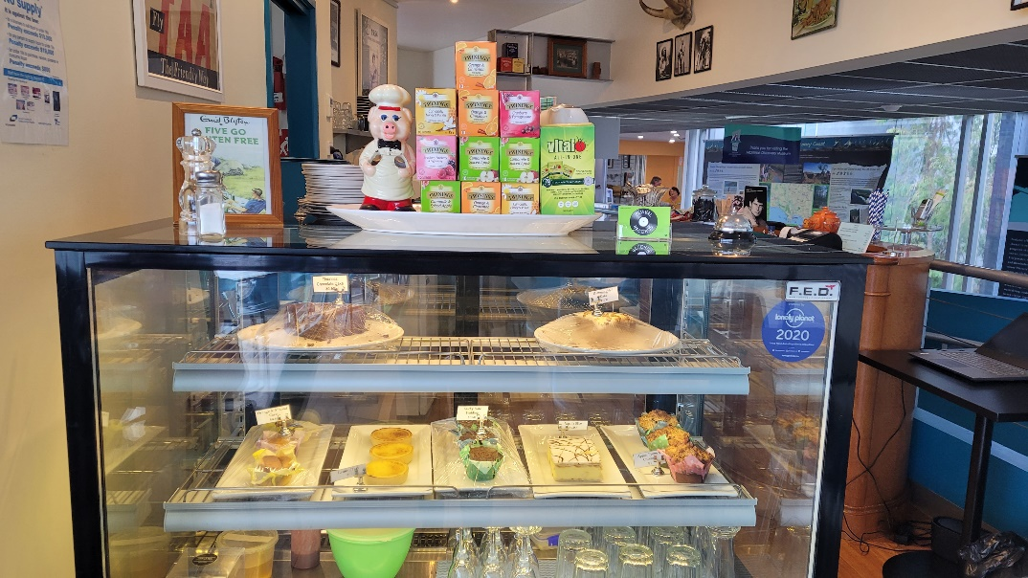

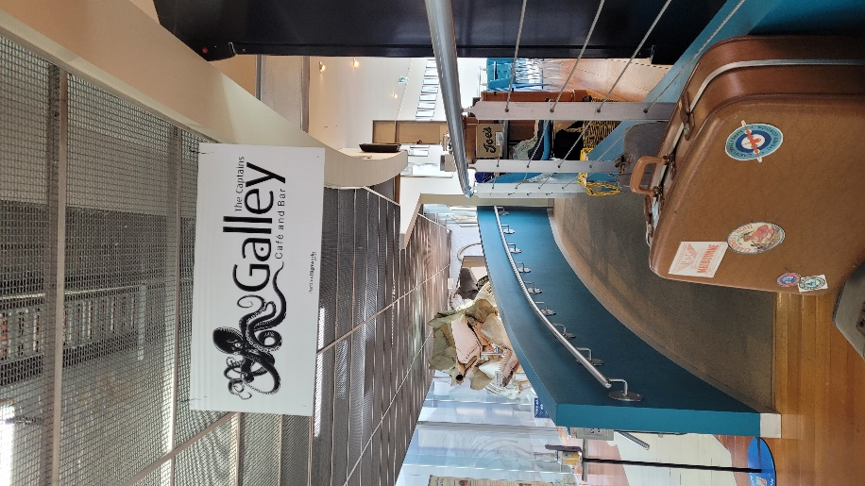
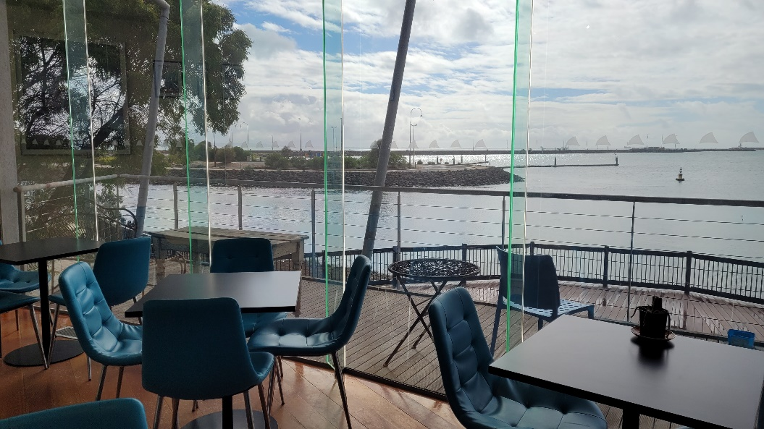

There are toilets at the Maritime Discovery Centre. If I want to go to the toilet, I need to tell my support person.

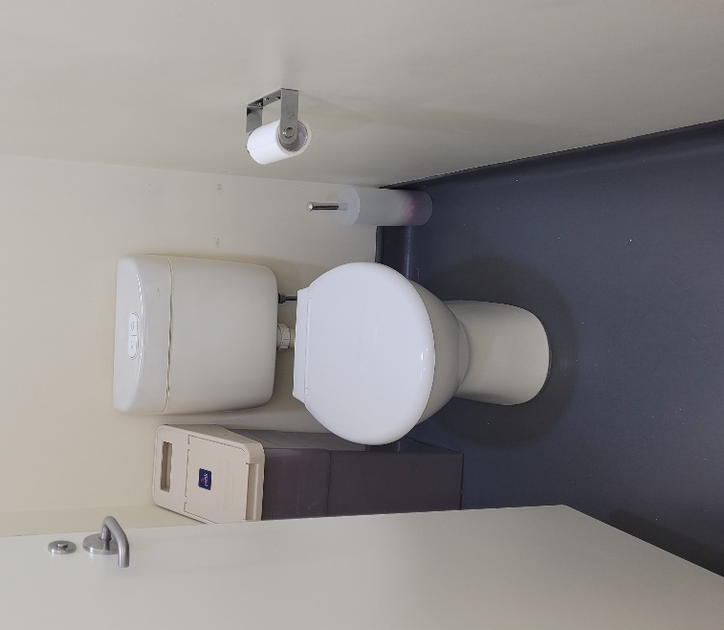
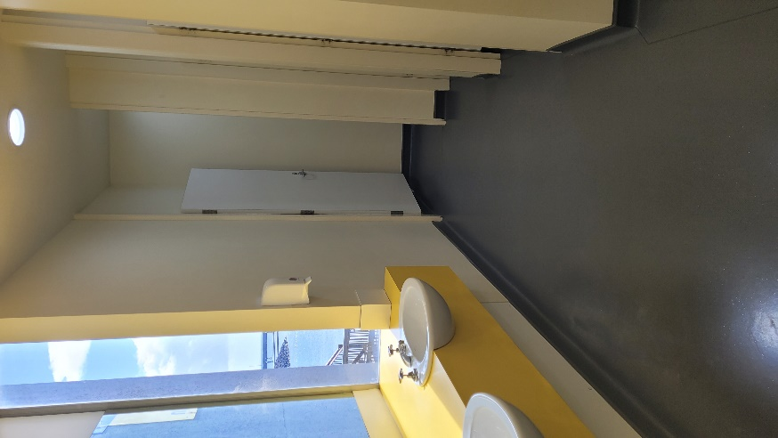

I had fun visiting the Maritime Discovery Centre.

