My visit to Portland Arts Centre

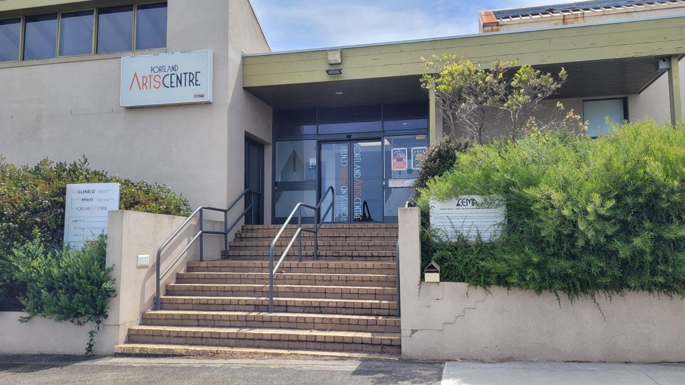

I am going to the Portland Arts Centre. The Portland Arts Centre is a safe place to visit.

I can walk up the steps or I can enter from the ramp.

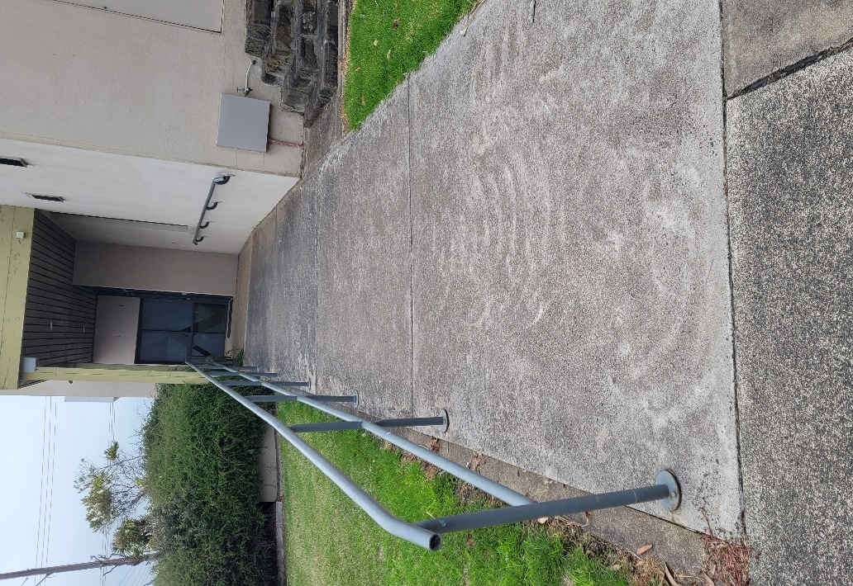
Sometimes there are a lot of people in the Portland Arts Centre. It can be loud. This is okay, they are all having a good time and I am safe.

Here I can look at art, go to a concert or see a play.

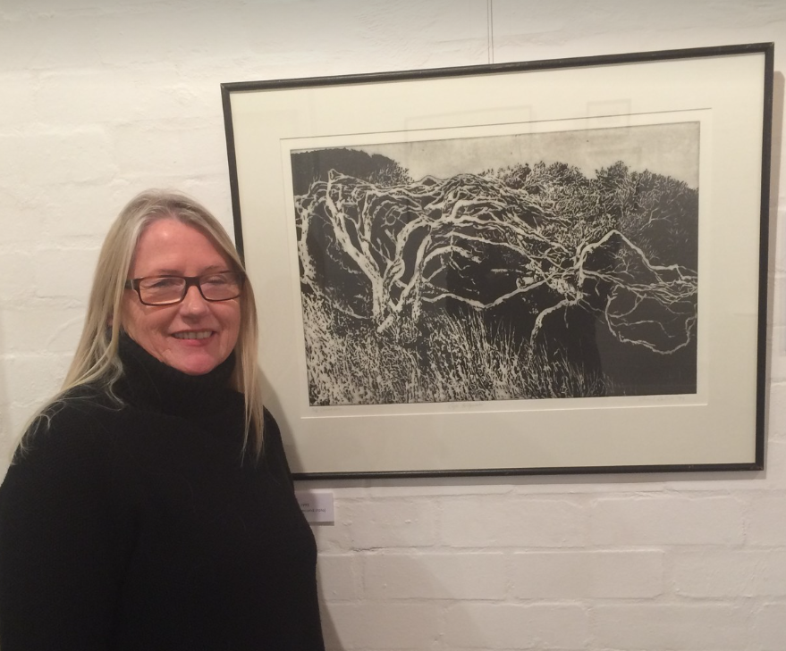

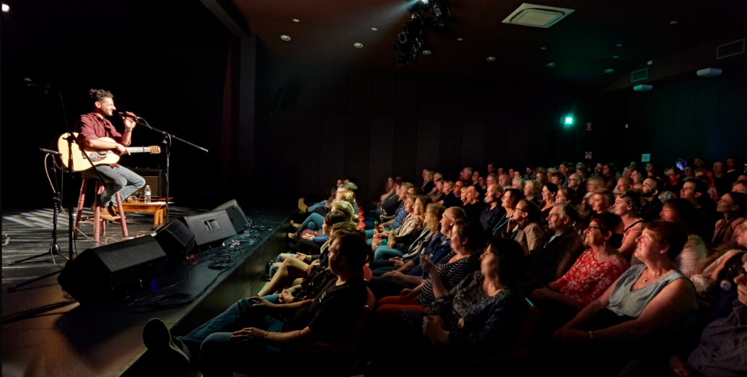

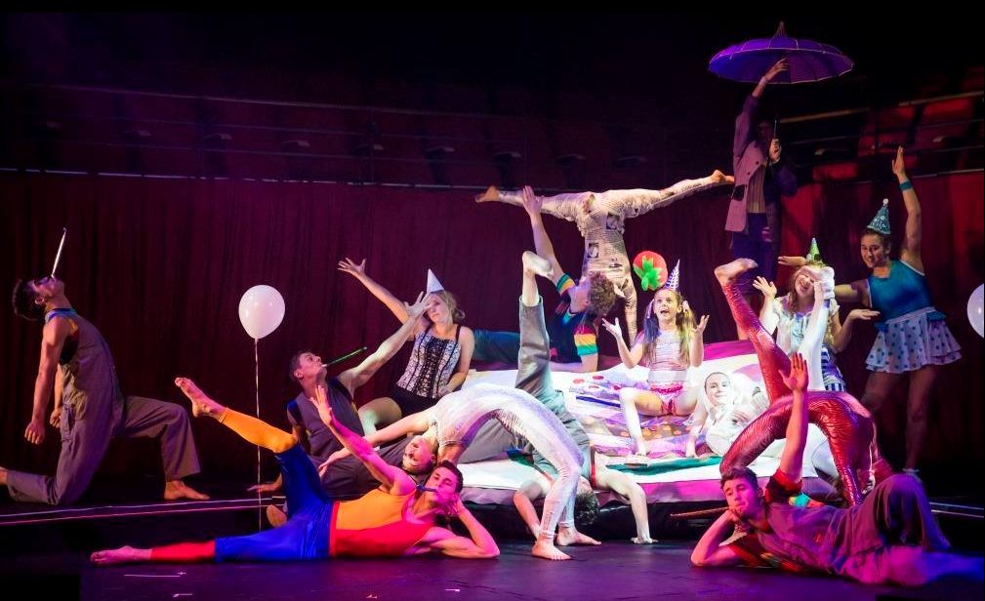

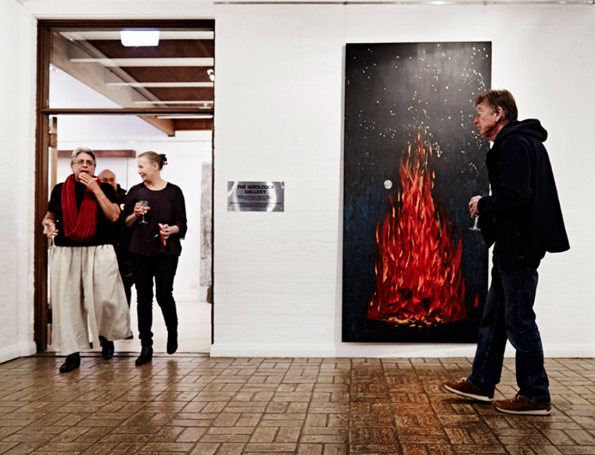
I walk through the front glass sliding doors into the entrance.

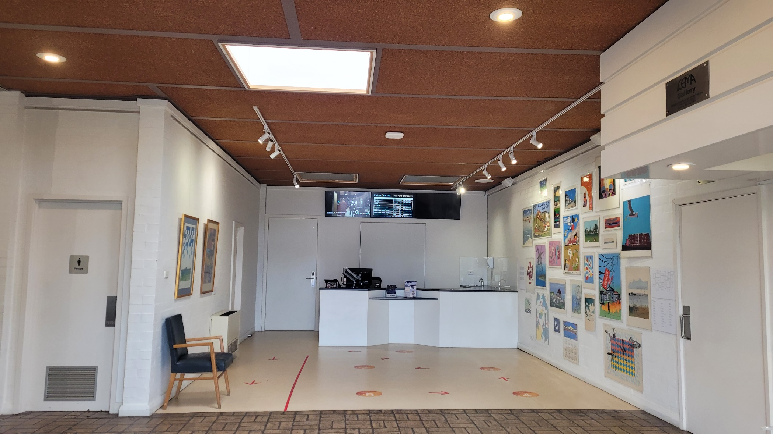

I can go into the Portland Arts Centre, and I can look at exhibitions that change regularly.

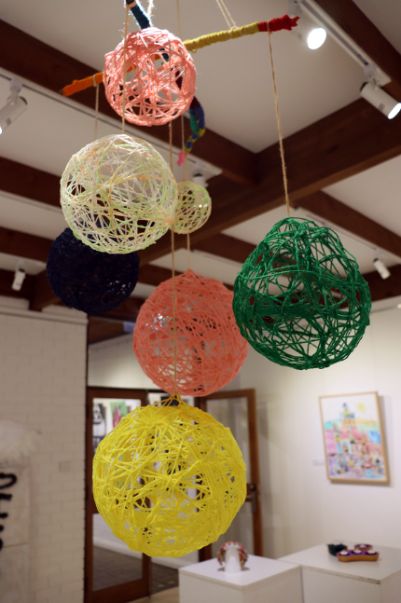
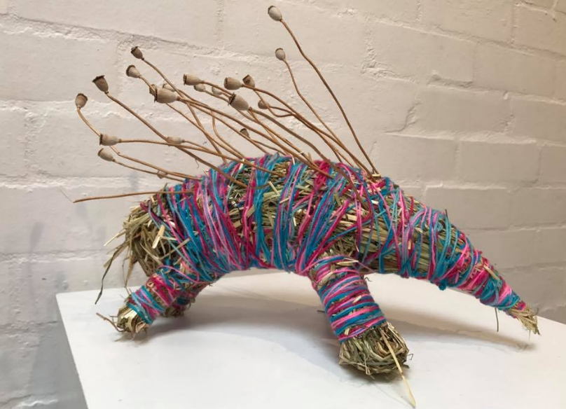

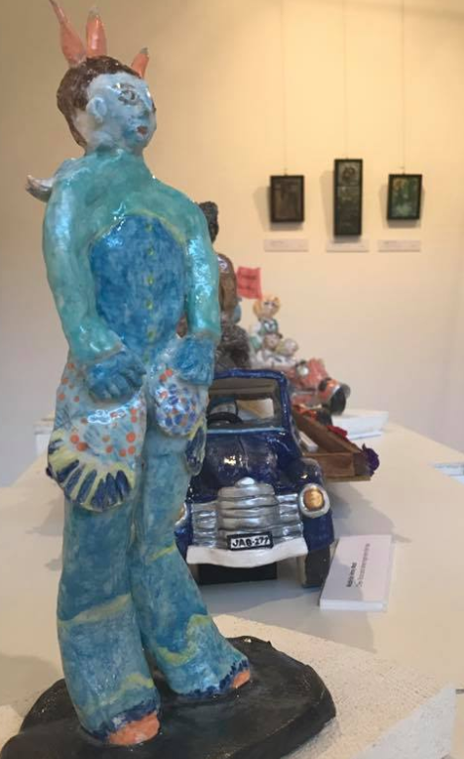
There are people who work at the Portland Arts Centre. I can ask them questions about the art, concerts or plays at the centre.

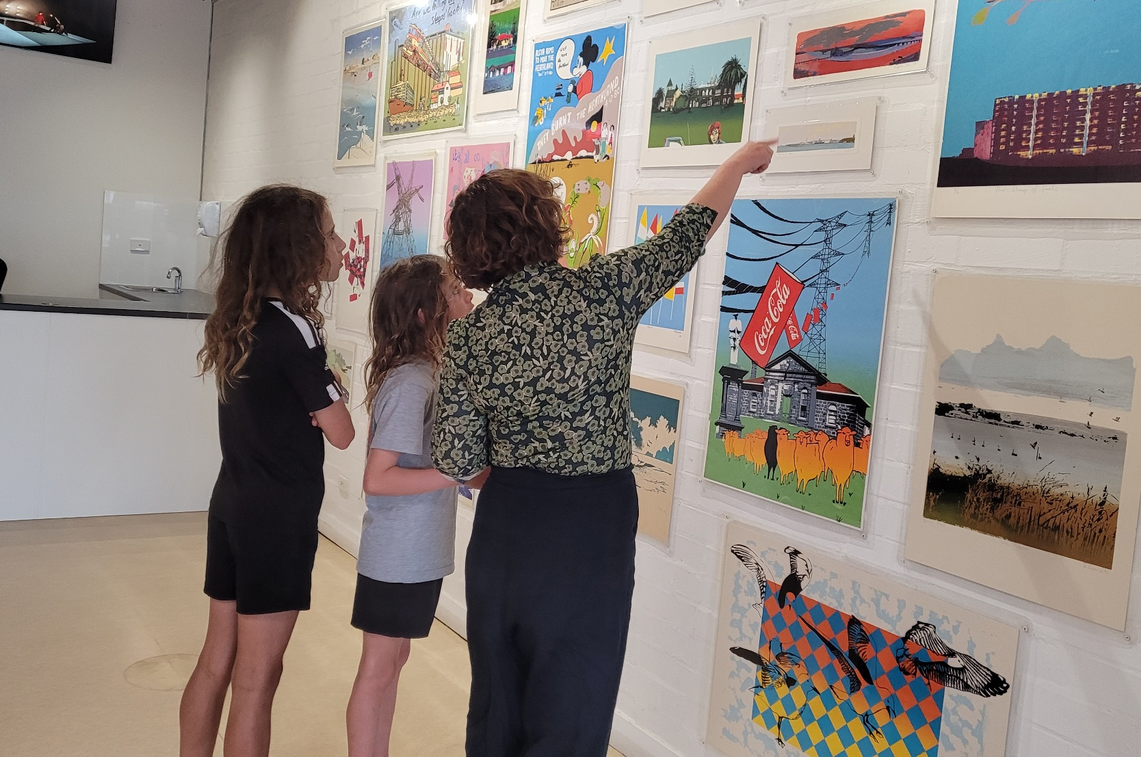

At the Portland Arts Centre there will be a door to get into the theatre and I will need a ticket to enter. My support person can help me get a ticket from the box office.

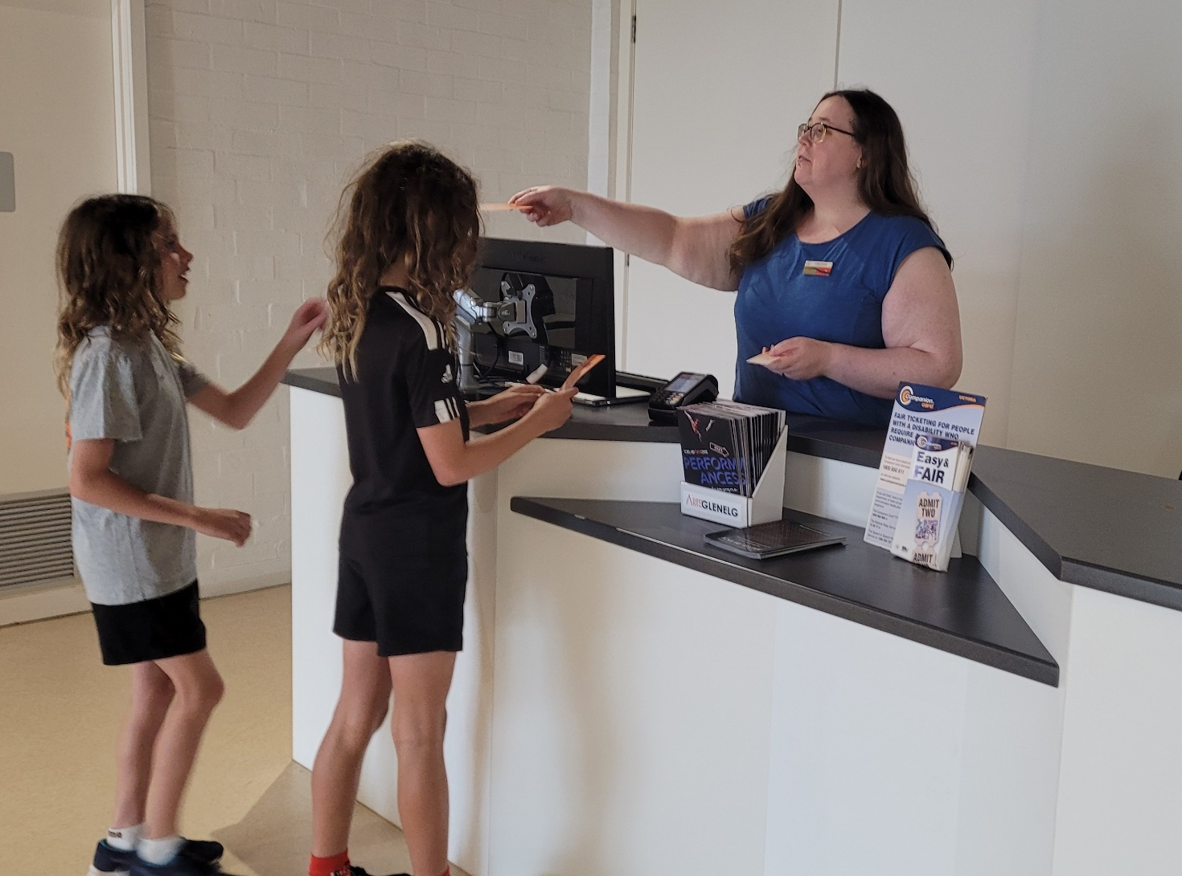

There are toilets at the Portland Arts Centre. If I need to go to the toilet, I need to tell my support person.

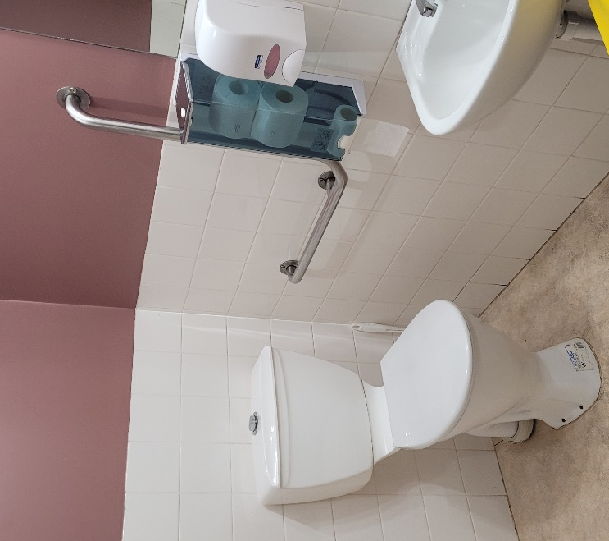
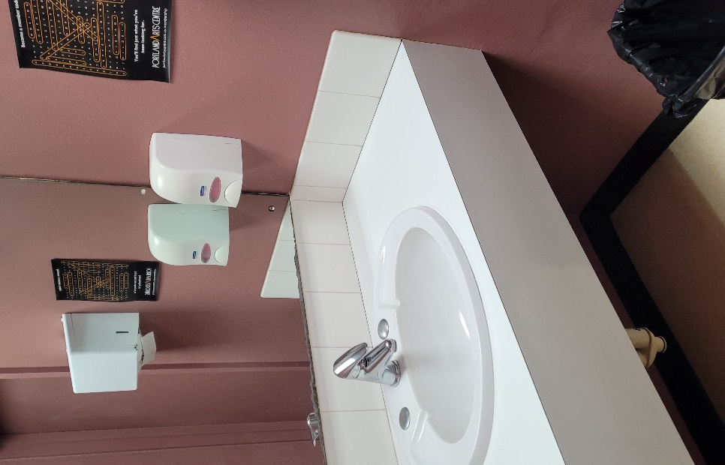
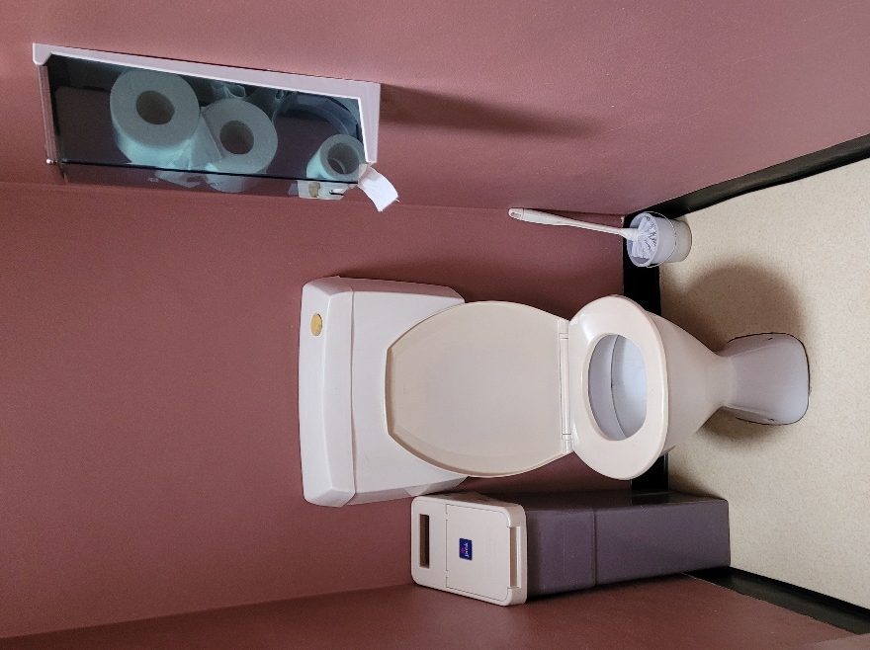

I had fun visiting the Portland Arts Centre.

