My visit to
Australian Kelpie Centre

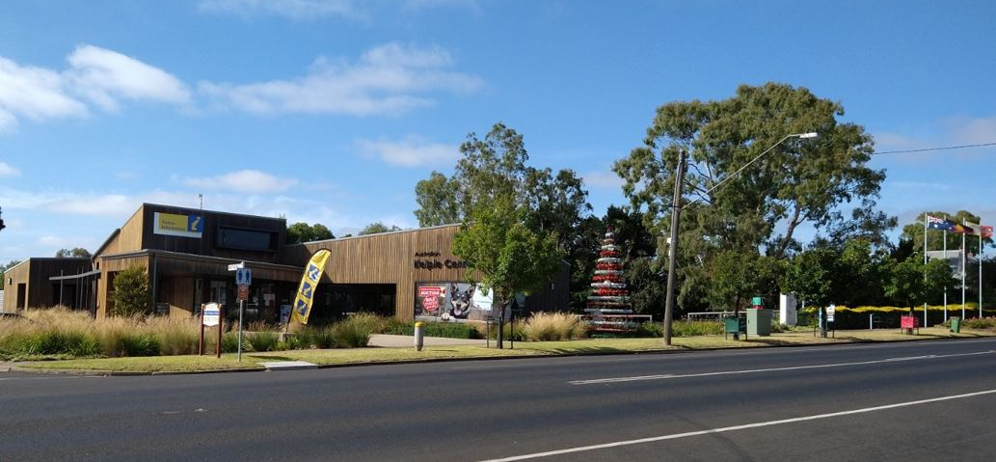
I am going to the Australian Kelpie Centre. The centre is a safe place to visit.

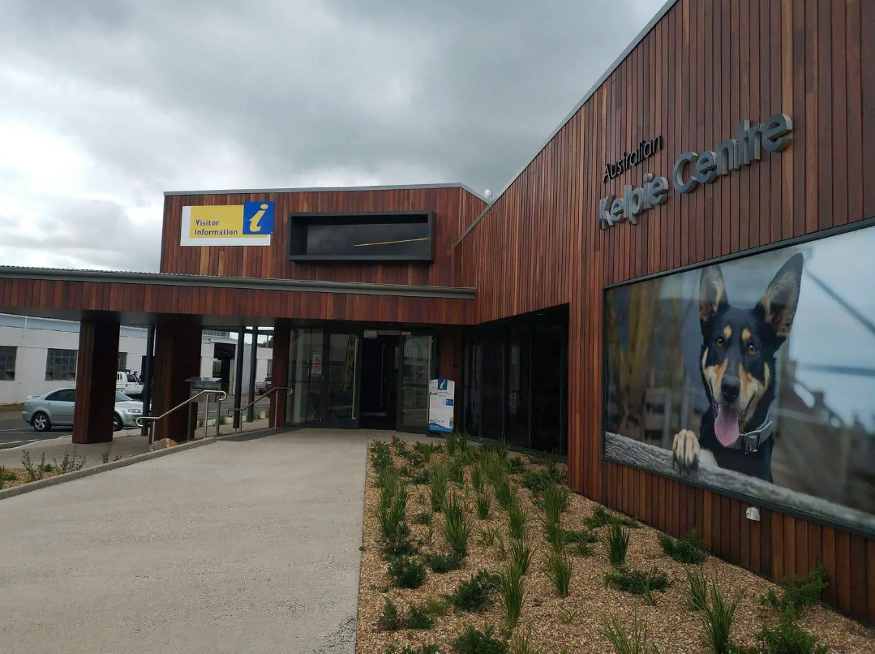

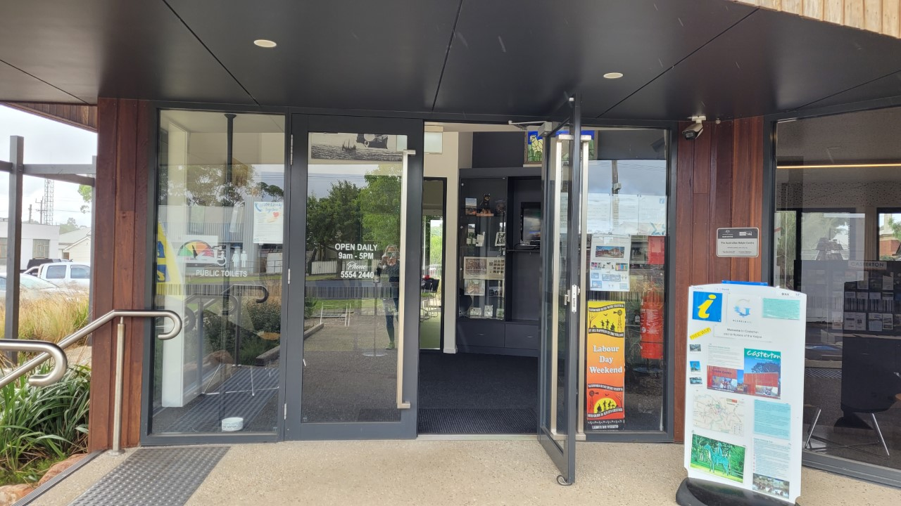
I open the front glass doors into the entrance.
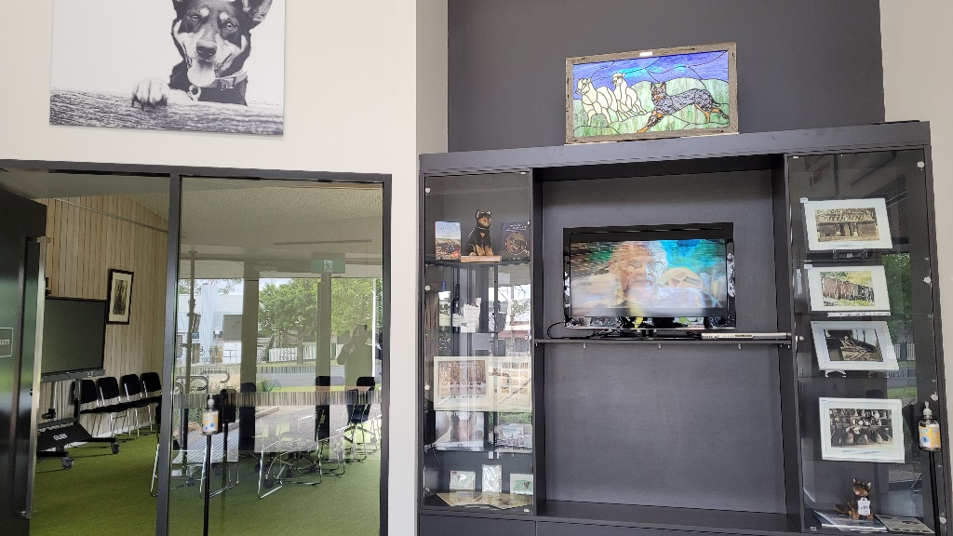
I can go into the Visitor Information Centre and look at what there is to do and see in and around the Glenelg Shire.
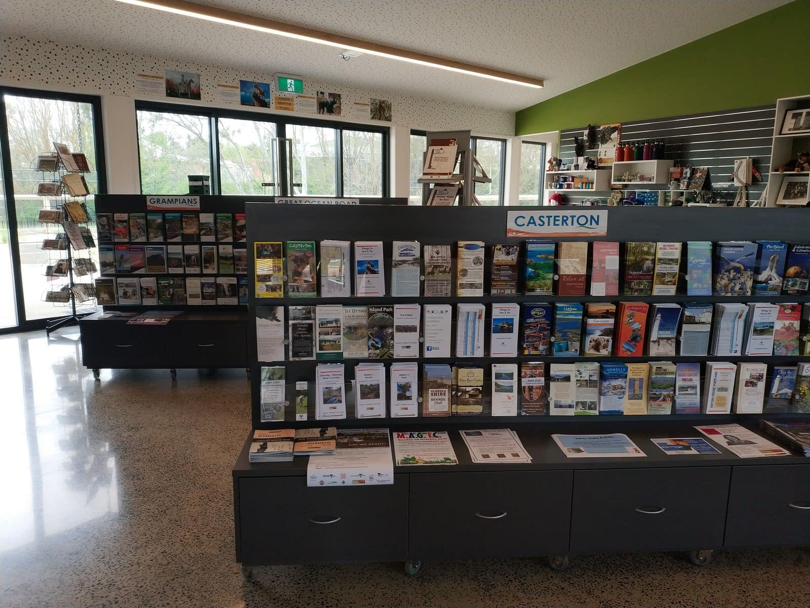
There are people who work at the Visitor Information and Australian Kelpie Centre. They are called Visitor Services Officers. They wear a uniform. I can ask them questions about anything in the Kelpie Centre or what there is to do and see in and around our Shire.
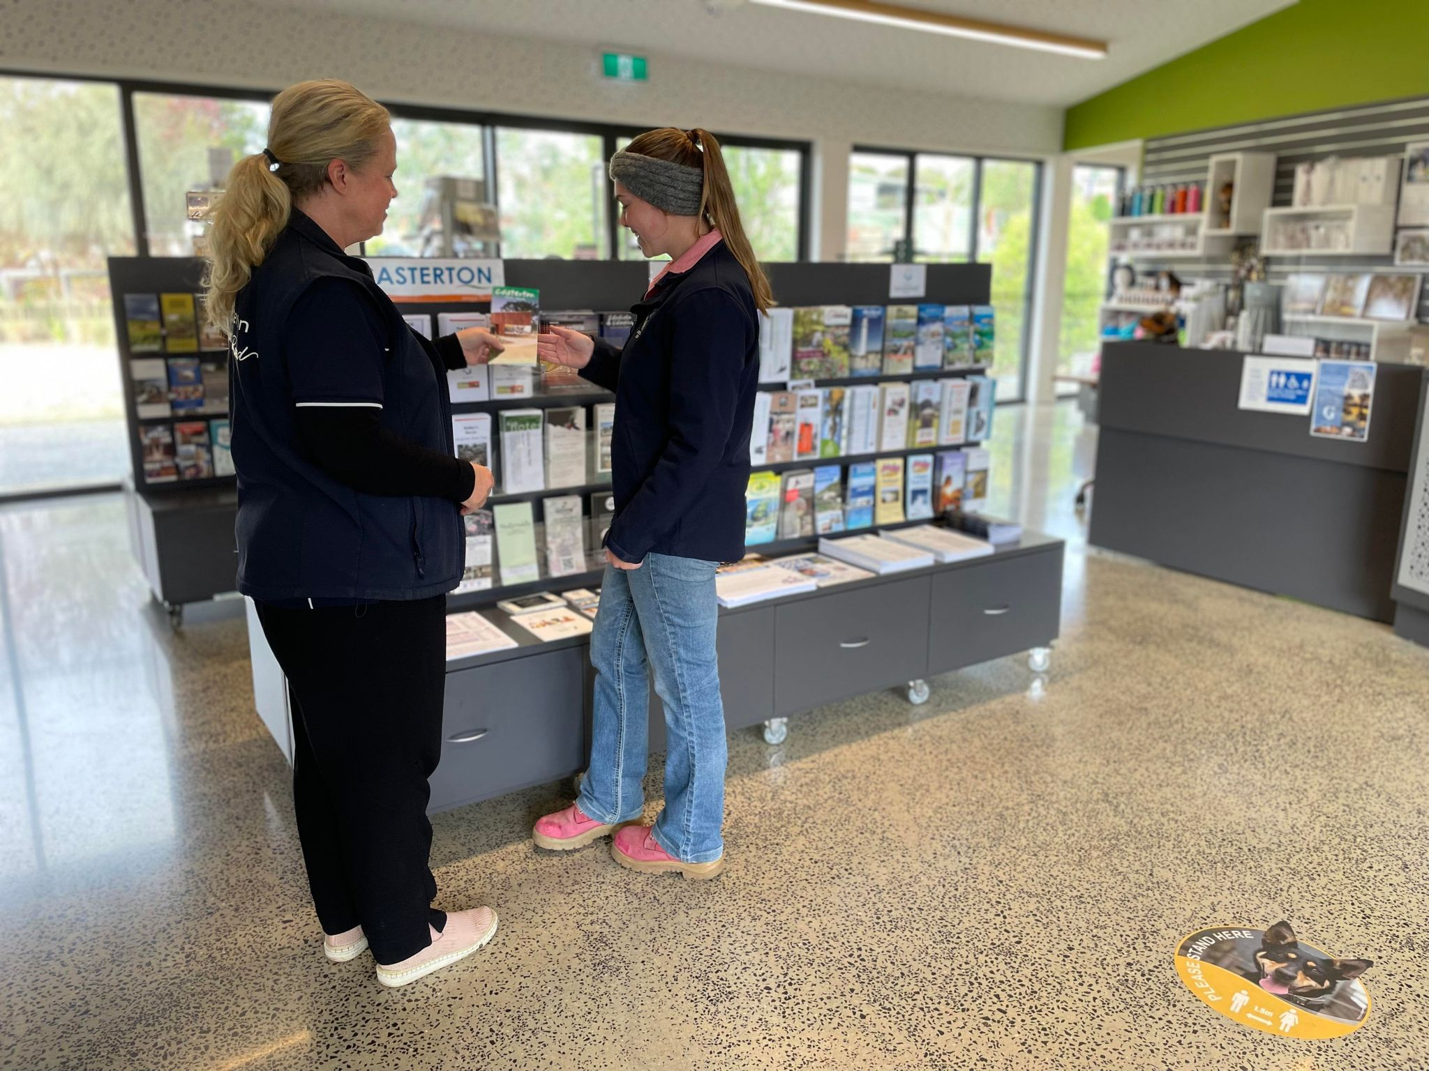

From the Visitor Information Centre I can enter the Kelpie Museum. The Kelpie Museum is free to enter.

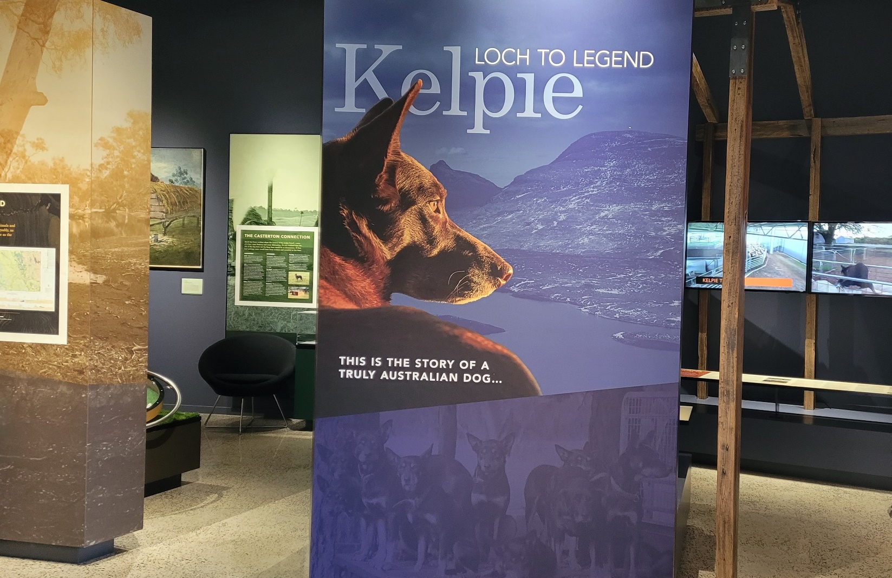

In the Kelpie Museum I can look at the displays and learn about the Kelpie dog and Aboriginal and farming history. There is a lot of Casterton history to see and read about.

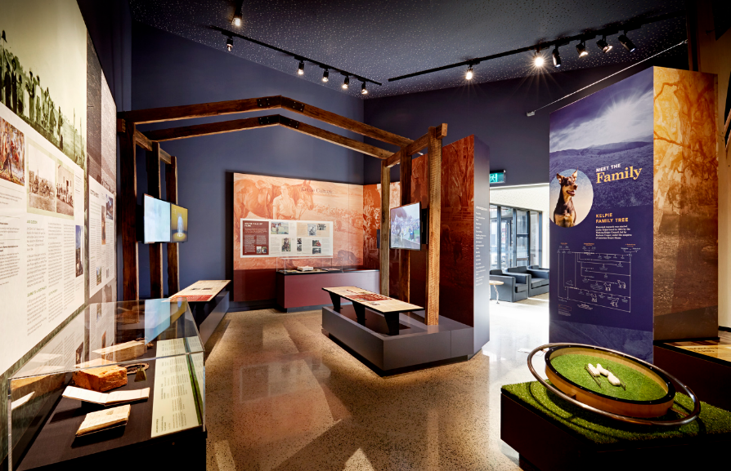
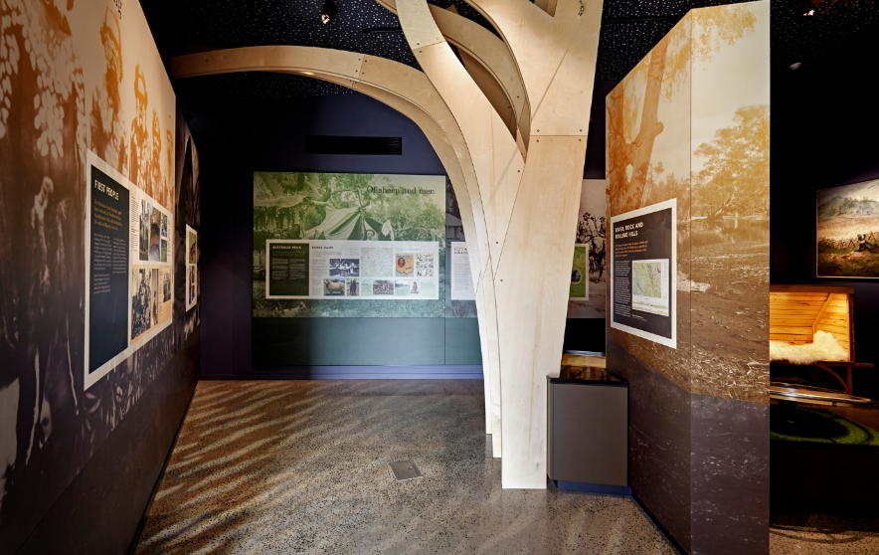
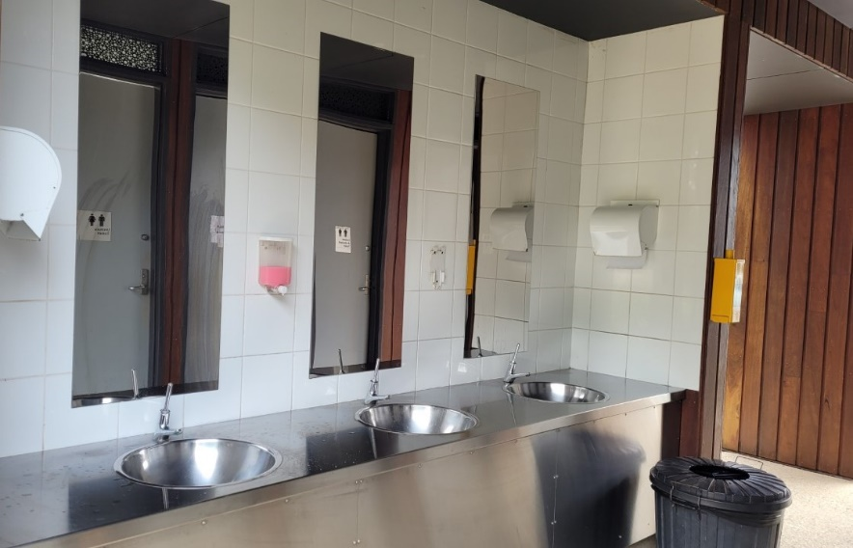
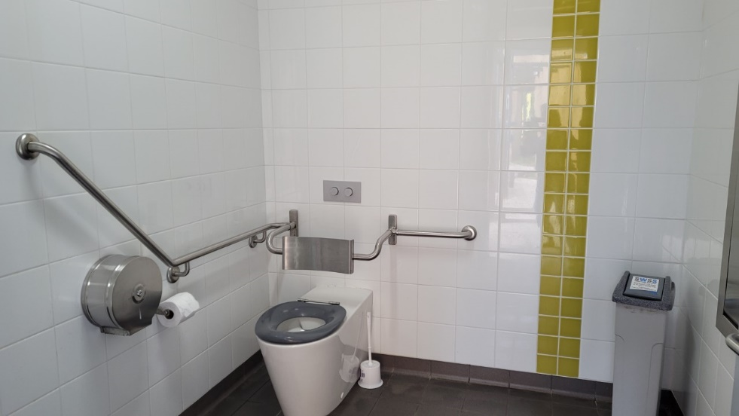
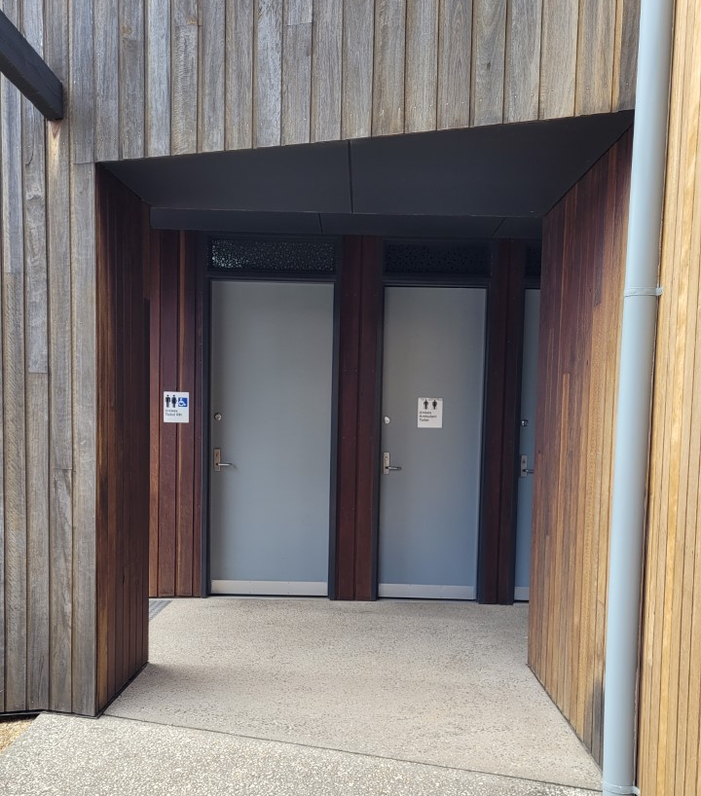
There are toilets outside at the Australian Kelpie Centre. If I want to go to the toilet, I need to tell my support.

I had fun visiting and learning about the area in and around Casterton and all about the Kelpies.
